LEGO Build Planner & Inventory Optimizer
Project Introduction
I like building and playing with Lego. I have a lot of sets but get bored with the ones I have and want to build something new.
I intend to create a programme that allows me to:
- Find out what pieces I’m missing
- Which existing sets contain those missing pieces
- Whether it’s cheaper to buy individual pieces or another used set
The programme will store what inventory I have:
Lego sets in my inventory:
- Starwars AT TE
- Speed Champions Supra
- Ninjago Zaynes Mech
- City Explorer
The programme will be able to select another set and outputs the percentage of parts I have for that given set and what set I can buy to make up for the missing pieces.

Project Road Map
Learn Lego Data => Build inventory System => Compare inventories => Store data in a database => build a user interface => Add other features

Learn Lego Data
Legos are sold in sets. What is a Lego set?
A Lego set is a collection of pieces and potentially minifigures designed to be assembled into a model.
Each set is assigned a unique product number.
Models can take apart and combined with other bricks to create a new or existing builds.
A Lego part is a single standardized lego component used in tandem with other components to create a Lego model.
A Lego inventory is a comprehensive, itemized list of all the parts and elements and minifigures required to build a set or catalogue bricks in a collection. It also includes piece counts, colors, element/design IDs.
A lego Part ID is a 4-5 digit number that is associated with a specific piece that is usually molded onto said piece. The lego part id identifies the part shape but not the colour. As shown bellow.
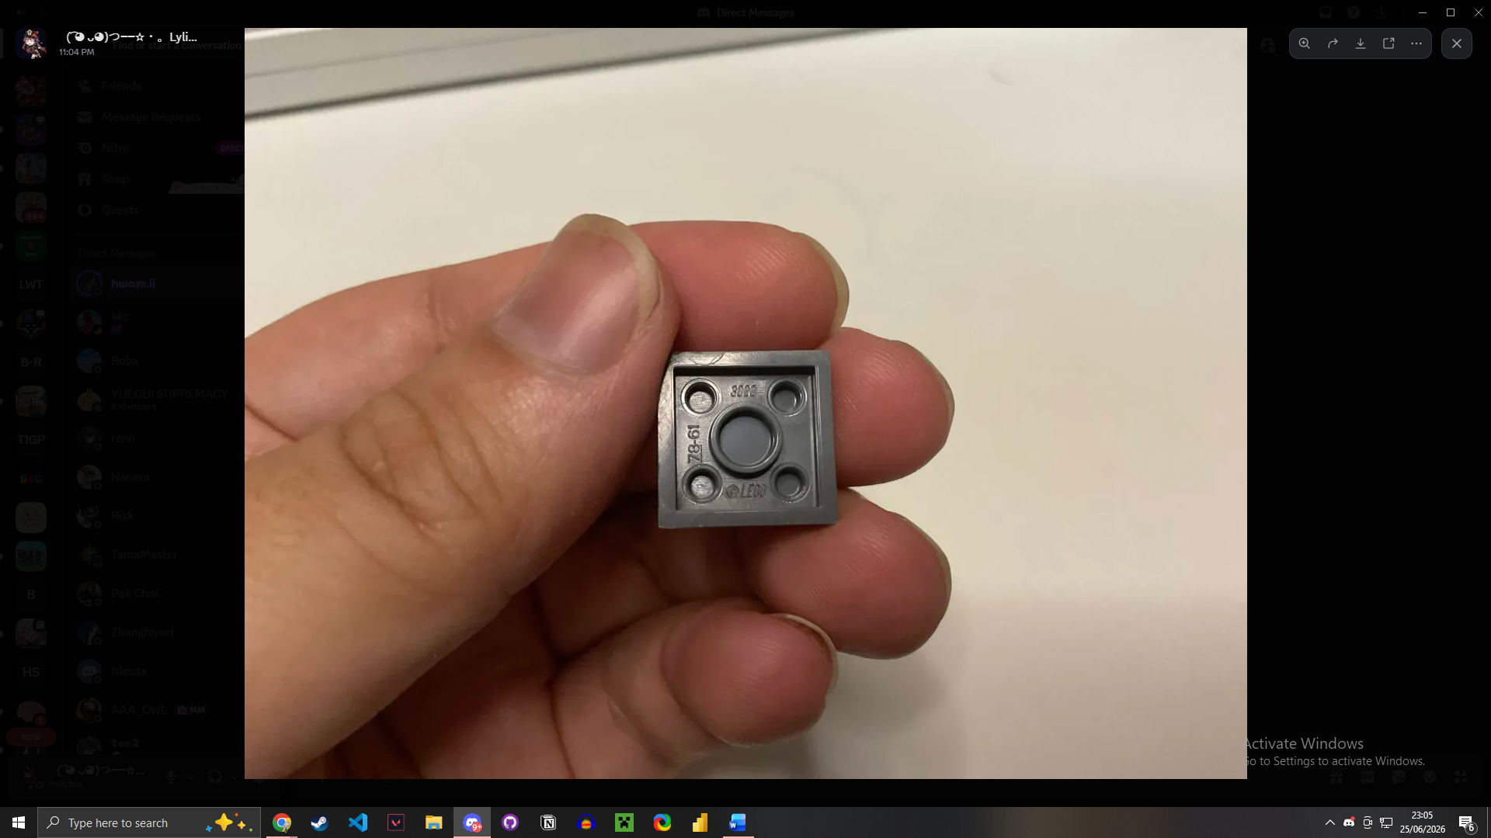
A lego Element ID is a 6-7 digit number that identifies the part shape and its colour. (not moulded onto the piece)
On bricklink this is how data on an item is stored:
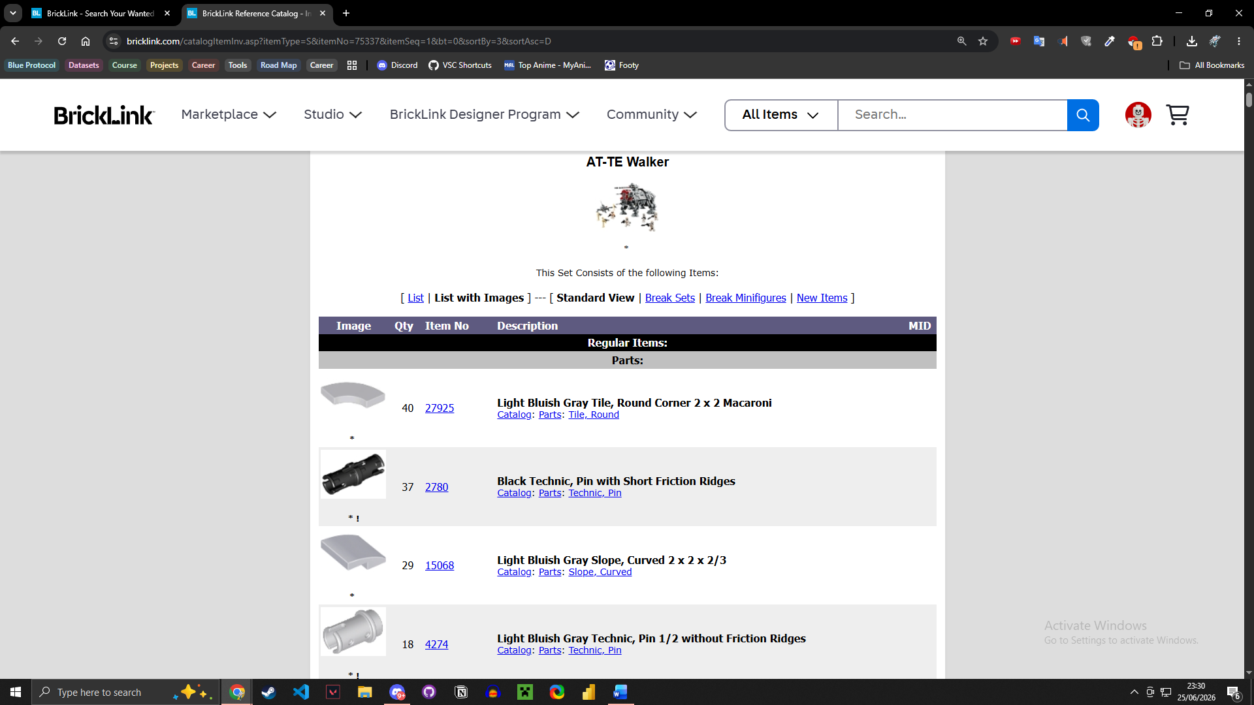
It is displayed with the item image, quantity, Element ID and description which contains the colour of the piece.

